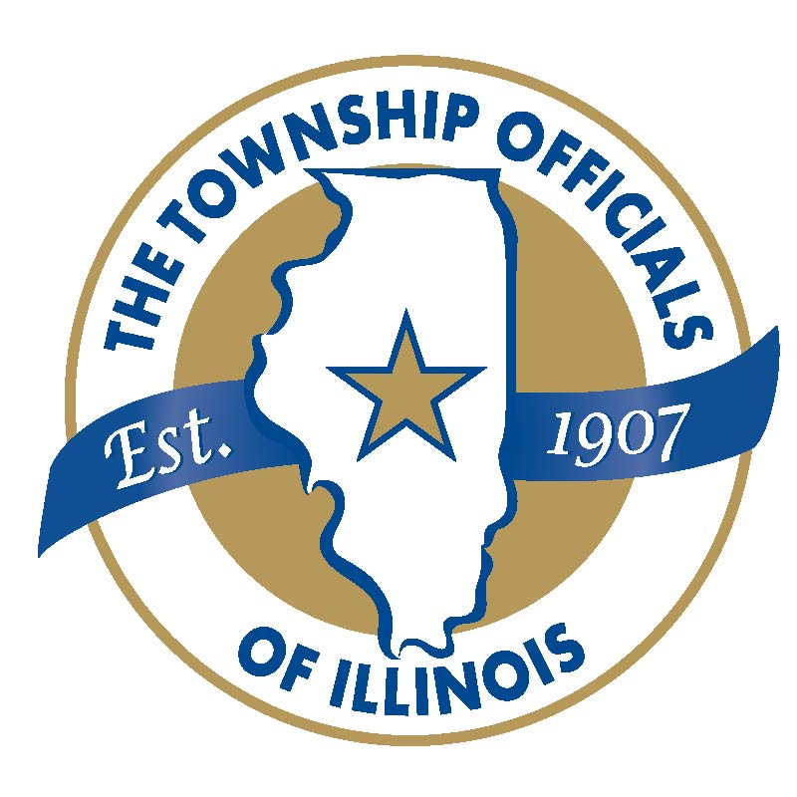
Illinois Township Association of General Assistance Caseworkers


THE ILLINOIS TOWNSHIP ASSOCIATION OF GENERAL ASSISTANCE CASEWORKERS DIVISION OF THE TOWNSHIP OFFICIALS OF ILLINOIS IS SPONSORING TWO AWARDS:
- 2018 Outstanding Caseworker of the Year
- 2018 Best Township Innovative Program

“2018 Outstanding Caseworker of the Year” must be nominated by the Supervisor, Administrator or General Assistance Director/Manager. Candidates should be nominated in relation to the following criteria:
- Service Provided
- Going Above and Beyond Serving Residents
- Improving Services for the Community
- Community Involvement and Impact
PLEASE SUBMIT A ONE PAGE SUMMARY DETAILING WHY THIS CANDIDATE SHOULD BE AWARDED
“2018 Outstanding Caseworker of the Year”

“2018 Best Township Innovative Program” must be nominated by the Supervisor or Direct Manager of the Program. This program must be utilized within the General Assistance Department and meet the following criteria:
- Program Description
- Service It Provides
- Outcomes, How This Program Benefits General Assistance Recipients
PLEASE SUBMIT A ONE PAGE SUMMARY DETAILING THIS PROGRAM AND WHY IT SHOULD BE AWARDED “2018 Best Township Innovative Program.”

AWARD NOMINATION FOR “2018 __________________________________”

NOMINEE NAME: ________________________ NOMINATOR NAME: ________________________
TOWNSHIP: _____________________________ TOWNSHIP: _______________________________
POSITION: ______________________________ POSITION: ________________________________
PHONE: ________________________________ PHONE: __________________________________
EMAIL: _________________________________ EMAIL: ___________________________________
SIGNATURE: ___________________________ DATE: ___________________________________

THE NOMINATION APPLICATION MUST BE SUBMITTED NO LATER THAN October 19th TO:

ILLINOIS TOWNSHIP ASSOCIATION OF
GENERAL ASSISTANCE CASEWORKERS DIVISION
c/o Mary Jo Imperato
Hanover Township
7431 Astor Avenue, Hanover Park, Illinois 60133
Email: mimperato@hanover-township.org
630-540-9085 ext. 233

PLAQUES WILL BE PRESENTED TO THE AWARD RECIPIENTS AT THE ANNUAL TOWNSHIP OFFICIALS OF ILLINOIS EDUCATIONAL CONFERENCE AWARDS BREAKFAST NOVEMBER 13, 2018 IN SPRINGFIELD.

